VIVA Bluescreen, REV 1.2

# Overview

The VIVA Bluescreen is a 1602 LCD driver board with four interface modes (UART, I2C, SPI, Bluetooth). The Bluescreen may be used as an accessory for microcontroller projects, a debugging tool for smartphone apps requiring Bluetooth communication, and a low-cost software development platform for the CC2541.

## Powering the Device

The device operates on 3.3V and can be powered through a 2.1mm DC jack, the VIVA Serial header or the PICkit3 header.

## VIVA Serial Header

The Bluescreen has a six (6) pin connector which may be used to power the board and interface via UART, I2C or SPI. The serial mode can be selected using the two (2) selector switches.

## Bluetooth

The Bluetooth is implemented by an HM10 module. The HM10 is fully connected to a 10-pin CC Debugger header – enabling the HM10 to be programmed and debugged. Using Texas Instrument’s Code Composer Studio, the HM10 can be used as a Bluetooth packet sniffer[1].

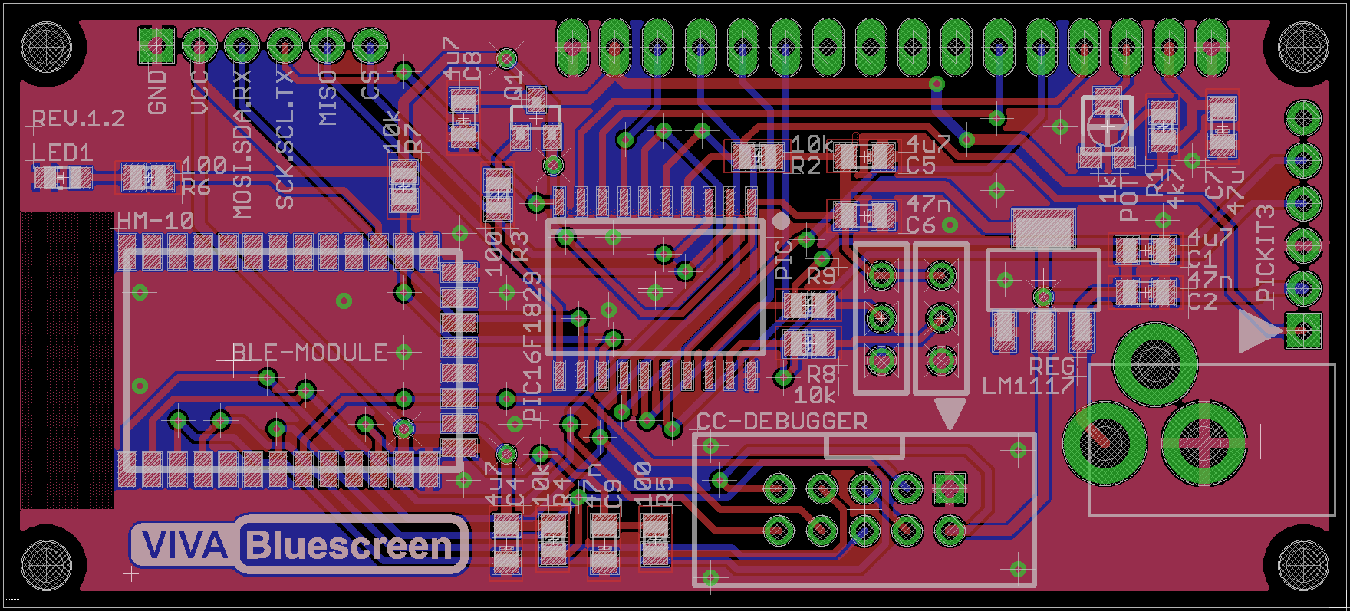

# Table of Contents

Overview 1

Powering the Device 1

VIVA Serial Header 1

Bluetooth 1

Table of Contents 2

Pin Designations 3

PIC16F1829 3

VIVA Serial Header 3

HM-10 4

Schematic (page 1) 5

Schematic (page 2) 6

Notes 7

# Pin Designations

## PIC16F1829

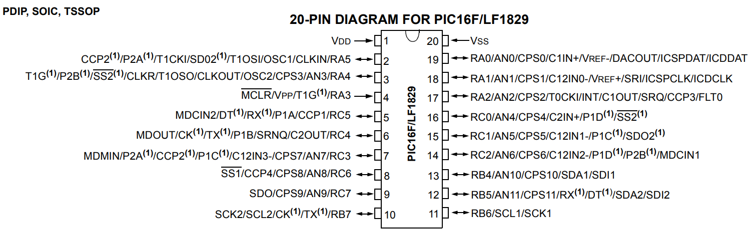

Figure - Pinout Diagram (source: microchip.com)

|  |  |  |  |  |
| --- | --- | --- | --- | --- |
| Pin # | PIC16  Pin Name | Destination | Description | NOTE |
| 1 | VDD | VDD | Power |  |
| 2 | RA5 | VIVA.5 | Serial Interface | SPI.MISO |
| 3 | RA4 | VIVA.6 | Serial Interface | SPI.CS |
| 4 | RA3 | MCLR |  |  |
| 5 | RC5 | BLE.TX | BLE UART |  |
| 6 | RC4 | BLE.RX | BLE UART |  |
| 7 | RC3 | LCD.D7 | LCD Data |  |
| 8 | RC6 | LCD.E | LCD Enable |  |
| 9 | RC7 | LCD.RS | LCD Register Select |  |
| 10 | RB7 | VIVA.4 | Serial Interface | UART.TX; I2C.SCL; SPI.SCK |
| 11 | RB6 | LCD.PWR | Switch LCD Power | Low = LCD “on” |
| 12 | RB5 | VIVA.3 | Serial Interface | UART.RX; I2C.SDA; SPI.MOSI |
| 13 | RB4 | BLE.SK | BLE System Key | Allows PIC to key HM10 |
| 14 | RC2 | LCD.D6 | LCD Data |  |
| 15 | RC1 | LCD.D5 | LCD Data |  |
| 16 | RC0 | LCD.D4 | LCD Data |  |
| 17 | RA2 | LCD.RW | LCD Read/Write |  |
| 18 | RA1 | B3 (ICSPC) | Button | Button Pulls Down |
| 19 | RA0 | B4 (ICSPD) | Button | Button Pulls Down |
| 20 | VSS | GND | Ground |  |

## VIVA Serial Header

|  |  |  |  |
| --- | --- | --- | --- |
| Pin # | Pin Name | PIC16 Pin Name | Functions |
| 1 | GND | - |  |
| 2 | VDD | - | Use to power the Bluescreen. (3.3V ONLY!) |
| 3 | VIVA.3 | RB5 | UART.RX; I2C.SDA; SPI.MOSI |
| 4 | VIVA.4 | RB7 | UART.TX; I2C.SCL; SPI.SCK |
| 5 | VIVA.5 | RA5 | SPI.MISO |
| 6 | VIVA.6 | RA4 | SPI.CS |

## HM-10

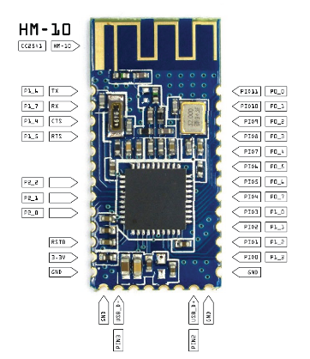

Figure - Pinout Diagram (source: github.com/nickswalker/ble-dev-kit/wiki/HM-10-Pinout)

|  |  |  |  |  |
| --- | --- | --- | --- | --- |
| HM-10 Pin # | HM-10  Pin Name | CC2541  Pin Name | PIC16  Pin Name | Note |
| 1 | TX | P1.6 | RC5 | CC-Debugger (P8, SPI.MOSI) |
| 2 | RX | P1.7 | RC4 | CC-Debugger (P10, SPI.MISO) |
| 3 | CTS | P1.4 |  | CC-Debugger (P5, SPI.CS) |
| 4 | RTS | P1.5 |  | CC-Debugger (P6, SPI.SCK) |
| 5 |  |  |  |  |
| 6 |  |  |  |  |
| 7 |  | P2.2 |  | CC-Debugger (P3, D-CLK) |
| 8 |  | P2.1 |  | CC-Debugger (P4, D-DAT) |
| 9 |  | P2.0 |  |  |
| 10 |  |  |  |  |
| 11 |  | RESET |  | CC-Debugger (P7, RESET) |
| 12 | 3v3 |  |  |  |
| 13 | GND |  |  |  |
| 14 | GND |  |  |  |
| 15 |  | SDA |  |  |
| 16 |  |  |  |  |
| 17 |  |  |  |  |
| 18 |  |  |  |  |
| 19 |  |  |  |  |
| 20 |  | SCL |  |  |
| 21 | GND |  |  |  |
| 22 | GND |  |  |  |
| 23 | PIO0 | P1_3 | RB4 | HM10 System Key |
| 24 | PIO1 | P1_2 |  | HM10 System LED / PIC Digital Output |
| 25 | PIO2 | P1_1 |  |  |
| 26 | PIO3 | P1_0 |  |  |
| 27 | PIO4 | P0_7 |  |  |
| 28 | PIO5 | P0_6 |  |  |
| 29 | PIO6 | P0_5 |  |  |
| 30 | PIO7 | P0_4 |  |  |
| 31 | PIO8 | P0_3 |  |  |
| 32 | PIO9 | P0_2 |  |  |
| 33 | PIO10 | P0_1 |  |  |
| 34 | PIO11 | P0_0 |  |  |

# Schematic (page 1)

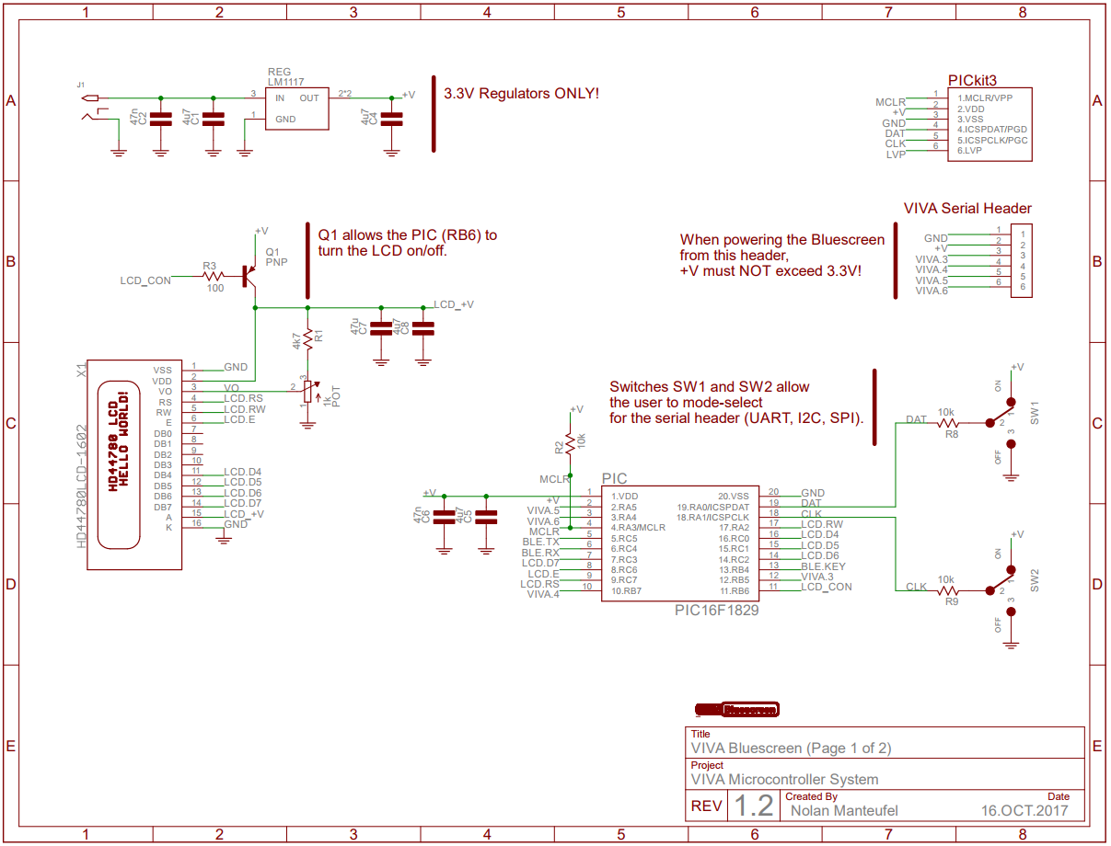

# Schematic (page 2)

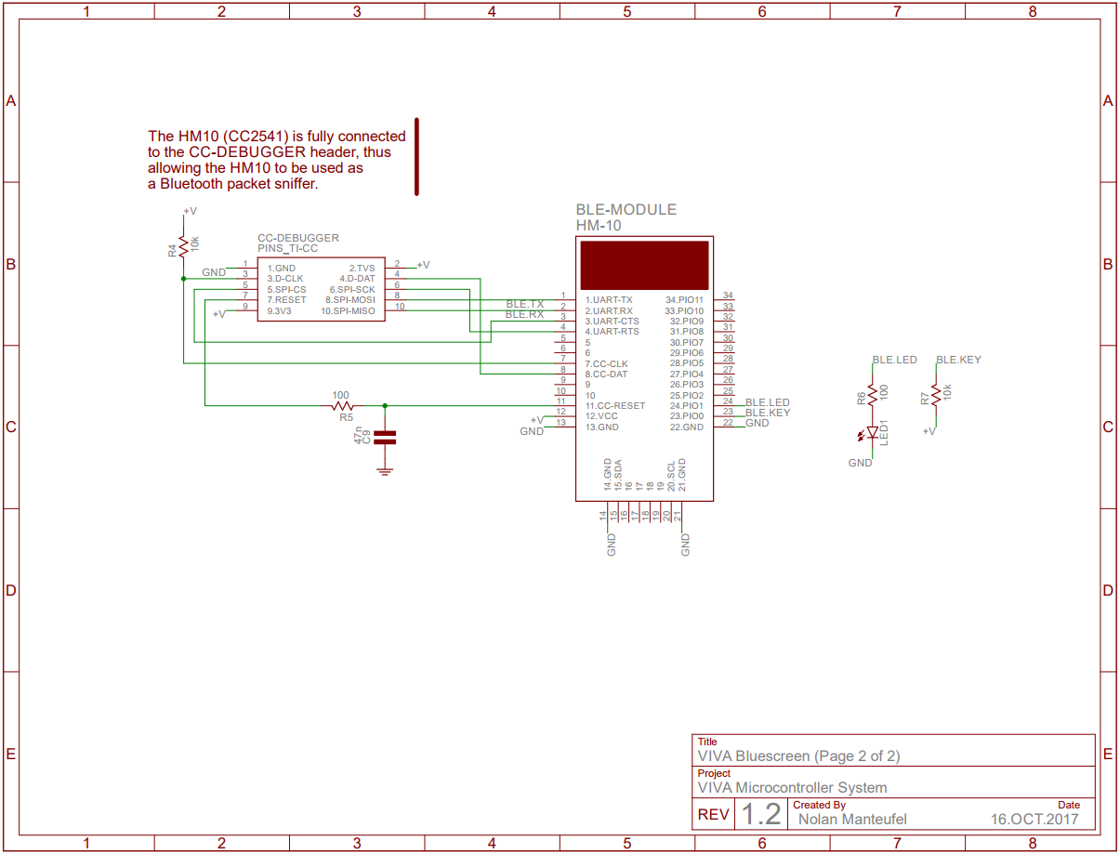

# Notes

1. Need to add link!